August 2017 Issue

Recipes

Annie’s Fruit Salsa and Cinnamon Chips

Serves 10
Ingredients

- Two kiwis - peeled and diced
- 2 Golden Delicious apples - peeled, cored, and diced
- 8 ounces of raspberries
- 1 pound of strawberries -sliced
- 2 Tablespoons of sugar
- 1 Tablespoon of brown sugar
- 3 Tablespoons of fruit preserves, and flavor
- 10 (10 inch) flour tortillas
- Vegetable oil cooking spray
- 2 Tablespoons of cinnamon

Photo courtesy of Creative Commons.

How to Make It

- In a large bowl, thoroughly mix kiwis, apples, raspberries, strawberries, white sugar, brown sugar and fruit preserves. Cover and chill in the refrigerator for at least 15 minutes.
- Preheat oven to 350 degrees F (175 degrees C).

- Coat one side of each flour tortilla with butter flavored cooking spray. Cut into wedges and arrange in a single layer on a large baking sheet. Sprinkle wedges with desired amount of cinnamon sugar. Spray again with cooking spray.

- Bake in the preheated oven 8 to 10 minutes. Repeat with any remaining tortilla wedges. Allow to cool approximately 15 minutes. Serve with chilled fruit mixture.

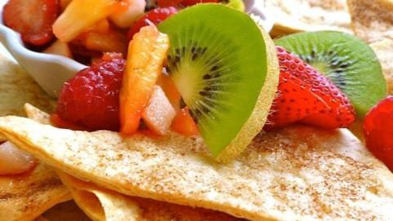

Sources: Network, Food “Healthy Recipes" Foodnetwork.com, 26 Jan. 2017

August 2017 Issue

Recipes

Mango Oatmeal Breakfast Smoothie

Serves 4
Ingredients

½ cup of orange juice
- ½ cup of frozen mango chunks
- ½ banana cup into chunks
- 1/3 cup plain yogurt
- ¼ cup of oats

Photo courtesy of Creative Commons.

How to Make It

1. Blend orange juice, mango, banana, yogurt, and oats together in a blender until smooth.

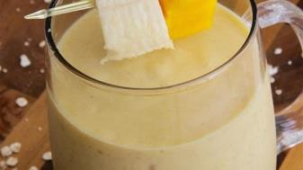

Sources: Network, Food. "Healthy Smoothie Recipes."Foodnetwork.com, 26 Jan. 2017

