Community Action Month T-Shirt Design Competition
Instructions: Draw your idea in the t-shirt templates below, or attach additional illustrated materials. If you are including text, please write the text in the box underneath each t-shirt. Then, fill out your contact information. Your design could be featured on all of this year‘s Community Action Month t-shirts.
Deadline: All entries must be in to marketing by April 11, 2022. Send scanned copies to marketing@ceoempowers.org, or drop off/inter-office mail them to the Administrative Building.
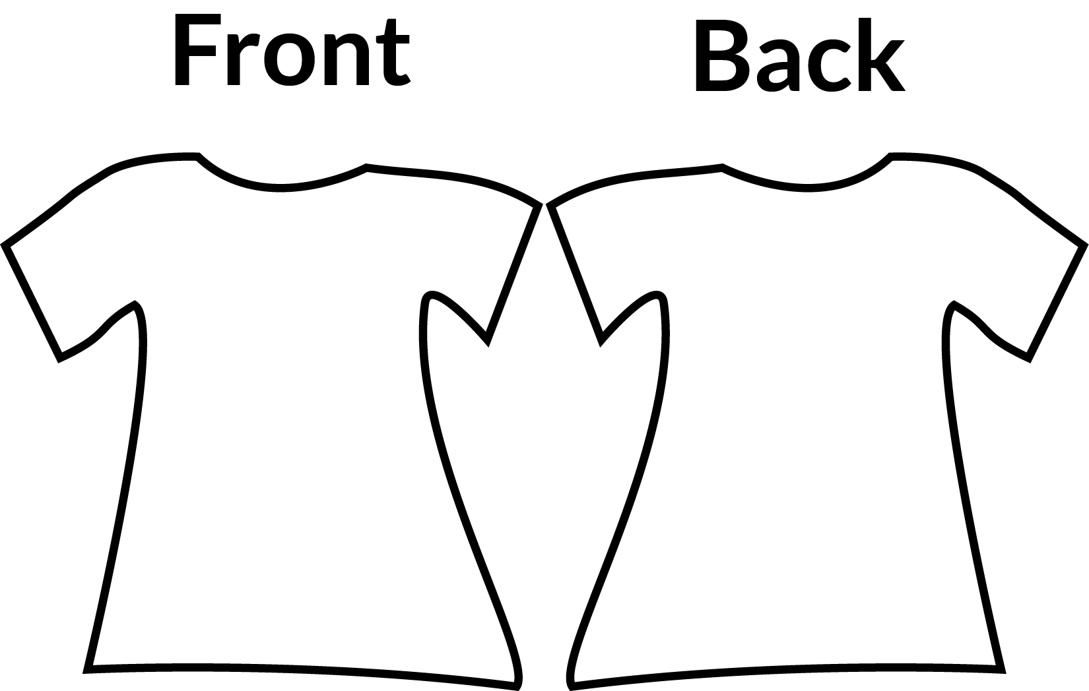
Write text here (back):
Write text here (front):

Name: _________________________________________________________________________________________________________
Center/CEO Location: _______________________________________________________________________________________
Email: _______________________________________________ Phone:________________________ Ext. __________________

