*Here is what is included in the bag!*

**NYS BABY BUNDLE**

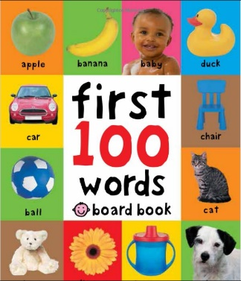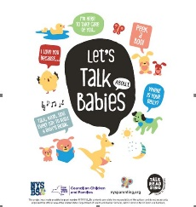    

* Starting Life Together NYS Parent Guide
* What to Do When Your Child Gets Sick
* Can Your Baby Hear You?
* Safe Sleep
* NYS Parent Portal
* Family Guide to NYS Early Childhood Services Prenatal through Age 5
* Talking is Teaching
* Board book for babies
* Local Resources
* Healthy Smile Toothbrush Brochure
* Baby Toothbrush

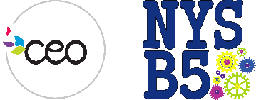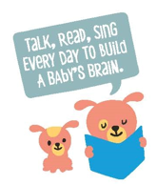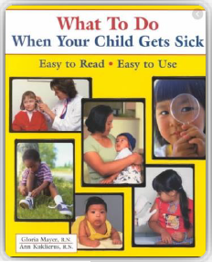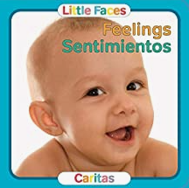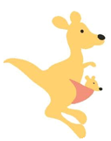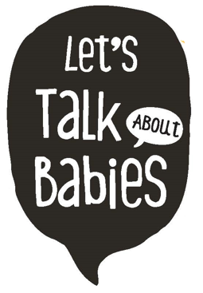

For more information please visit:

[https://www.ccf.ny.gov/council-initiatives/nysb5/other-information-2/](https://gcc02.safelinks.protection.outlook.com/?url=https%3A%2F%2Fwww.ccf.ny.gov%2Fcouncil-initiatives%2Fnysb5%2Fother-information-2%2F&data=04%7C01%7CAmanda.Briell%40ccf.ny.gov%7Ce46336a401904b03949408d9f70e8c65%7Cf46cb8ea79004d108ceb80e8c1c81ee7%7C0%7C0%7C637812464118672663%7CUnknown%7CTWFpbGZsb3d8eyJWIjoiMC4wLjAwMDAiLCJQIjoiV2luMzIiLCJBTiI6Ik1haWwiLCJXVCI6Mn0%3D%7C3000&sdata=OA8UQxQe4B3SVXHEYfov2GNQPeQLFrB71iyf6%2BZsrU0%3D&reserved=0)

Scan for the Parent Survey: