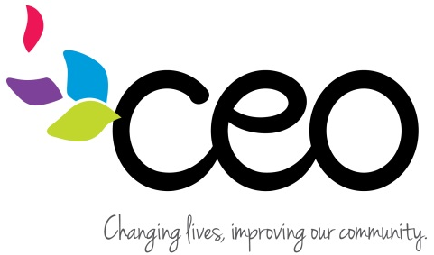

Health Phase-In Form

Child’s Name: __________________________Birthdate: _______________Classroom: ______________

- Does your child have any special health conditions?
Check all that apply.
 | YES | NO
Asthma
Allergies
Seizures
Other
_____________________________________________________________________________
- Does your child have any food restrictions due to religious beliefs? Circle: YES or NO
Please provide details below:
____________________________________________________________________________________________________________________________________________________________

- Does your child have any food restrictions due to an allergy or intolerance? Circle: YES or NO
Please provide details below:
____________________________________________________________________________________________________________________________________________________________

- Does your child require a special diet due to a medical condition? Circle YES or NO
Please provide details below:
______________________________________________________________________________

- Will your child need any medications in programming? Circle: YES or NO
___________________________________________________________________________

If you answered “YES” to any of the above questions, you will require a follow up call from a nurse to review and complete required medical documents before your child can start.

Parent signature__________________________________________ Date: _________________
Staff signature___________________________________________ Date: __________________
2/2022

