Adding a Child Profile
Note: You should only create a new profile for children who are newly enrolled to CEO. Children transferring from another classroom, another center or home-based care have an account already created that you will be given access to. If you have any questions about children’s accounts, please reach out to your Education Specialist.
-At the top of the page click Child Profiles, then on the left click Add Child Profile
-Fill in all field marked with a red asterisk *
-Refer to COPA for correct spelling of name and DOB
- If you are unsure if the child was born premature, please ask your Family Advocate
- Use the center’s address and phone number
- Enter the child’s start date for Date of Admission to Monitoring Program
-Click Save at the bottom of the page
-Back at the top, click Child Profiles, search for the child and click on their name
-On the left click Add Existing Caregivers, find yourself and your co-teachers and Add
-Go back with Return to Child’s Profile on the left
-On the left click Add Provider/Reviewer, click to check off the corresponding boxes for yourself and your co-teachers and click Add at the top right of the box
Note: If you find that you or a co-teacher do not appear on the list of Existing Caregivers or Providers/Reviewers please reach out to your Education Specialist for help.

How to print ASQ Packets
-At the top of the page, click Screening Management
-To the left, Under Packets, click View/Print Packets
-ASQ-3 English Questionnaire will be the first row, click View in the Actions column
-On the next page find and click Download in the bottom right of the box
-In the pop-up window, select the correct assessment based on the age of the child
-Print and complete the questionnaire
-Follow instructions for Entering an ASQ into the system

Entering an ASQ
-At the top of the page click Child Profiles, search using child’s info and click their name
-Scroll down to the blue Child Screenings tab and click the gray Add tab to the right
-In the pop-up window click OK to continue without a consent form
Note: CEO does receive consent from families at enrollment to conduct child assessments
-Complete the form on the following page
- Select yourself as the Caregiver and Provider who completed screening
- Questionnaire type is ASQ-3 English
- Short/Long Form: Select Long Form to generate the full ASQ with questions, if you complete the ASQ on paper ahead of time you may select Short Form to just input your answers.
-Click Save
-Complete the Questionnaire

ASQ Referrals
Note: ASQ results display each dimension as a black-gray-white scale and the child’s score for each dimension appears as a star somewhere on the scale. In general, scores in the white zones are above the cutoff for normal development; The child’s development is on schedule. Scores in the gray zone are close to the cut off for what is expected at the child’s current age; Their development in this area should be monitored. Scores in the back zone are below the cutoff and indicate that the child may need additional assessments or professional supports.
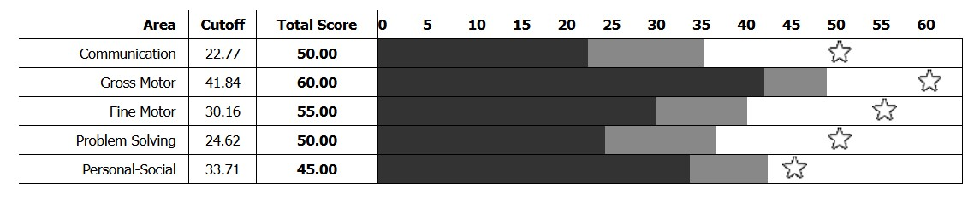

Children should be flagged for a referral on the Ed Doc if:
- They have two or more scores in the gray zones
- They have one or more scores in the black zones

ASQ Print out for Parent Teacher Conferences
- Go to the child’s profile.
- Under Child’s Screenings click on the most recent ASQ (this will be highlighted in blue).
- This will bring you to the ASQ you have filled out. On the right side of the page, under quick links, click on Print Information Summary. The information summary page will download onto your computer.
- Open the information summary and print the first page.
- This will be given to the parents and discussed.

