Toothbrushing in the Classroom
- All children with teeth will be given the opportunity to brush in the classroom once daily. Infants will participate in toothbrushing once the first tooth erupts (6-12 months).
- Time of day for toothbrushing is to be determined by classroom teacher (preferably following a meal).
Toothbrush & Toothpaste Storage:
- Toothbrushes should be stored in the appropriate toothbrush rack out of reach of children.
- Toothbrushes should be labeled with the child’s name and separated in individual spaces in the toothbrush rack to prevent touching.
- Toothbrushes should be replaced every 3 months, if the bristles are worn, if a child is sick, or if the toothbrush becomes contaminated with a dirty surface.
- Each child should have his/her own labeled toothpaste tube or if toothpaste from a single tube is shared among the children, it should be dispensed onto a clean piece of paper towel or paper cup for each child rather than directly on the toothbrush.
- Toothbrush racks should be sanitized in the dishwasher if available or cleaned with SPRAY BLEACH SOLUTION #1 (for food contact surfaces- see procedure) biweekly and anytime they are visibly soiled.
Resources for classroom:
Toothbrushing videos for the classroom:
Elmo’s Toothy Dance https://youtu.be/_vM5dcHXE_U
Brush with Elmo https://youtu.be/XFCzM0wXTp8
Brush Your Teeth to This Song https://youtu.be/AcYCMJvdupI

Resources for teaches:

Steps for Toothbrushing at the Table https://www.ihs.gov/HeadStart/documents/ClassroomCircleBrushingPoster.pdf

Video on Steps for Toothbrushing at the Table
https://eclkc.ohs.acf.hhs.gov/video/steps-toothbrushing-table-growing-healthy-smiles-early-care-education-programs

Toothbrushing Procedure (post in your classroom):

- Wash your hands

- Prepare the appropriate amount of fluoride toothpaste onto a clean paper towel or cup for children 2 years old and up. For infants to 2 years old add only a smear of non-fluoride toothpaste onto a clean paper towel. If non-fluoride toothpaste is not available, use only water.

Infant -3yrs 3yrs-6yrs
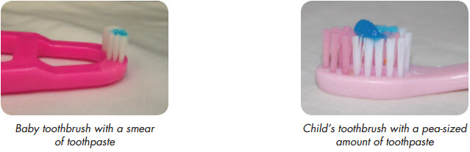

- Instruct the child to brush appropriately. If assisting a child, wear gloves. Wash hands and change gloves in between assisting multiple children.

- Brush for 2 minutes- use a song, video, or timer.

- Instruct the children to spit out the toothpaste after brushing. If they are unable to spit, have the child tilt his or her mouth down so that the toothpaste can dribble out into the sink or a cup.

- If children are spitting into the sink, sanitize the sink in between each child’s use. Children can spit into a cup as an alternative method.

- Rinse toothbrush and place toothbrush in appropriate spot in toothbrush rack, bristles up, to air dry.

- Wash your hands and the child’s hands.

