**Adding a child**

*Note: You should only create a new profile for children who are newly enrolled to CEO. Children transferring from another classroom, another center or home-based care have an account already created that you will be given access to. If you have any questions about children’s accounts, please reach out to your Education Specialist.*

-At the top of the page, select *e-DECA Management*

-From that menu, select *Manage Children* and then *Create a New Child Record*

-Enter the child’s last name, first name, date of birth and entry date (start date).

*Note: Please ensure children’s information is entered correctly including the spelling of their name and correct date of birth. If unsure, refer to COPA for correct information.*

-Under Site/Group Assignments, select the appropriate classroom for the child and move it to the right using the orange arrow key.

-Click Submit and look for a message in red text confirming your changes.

**Completing an e-DECA**

*Note: It’s best practice for teachers to spend at least one month with a new child before completing their assessments. Additionally, assessments must be complete by the child’s 45-day deadline. If you need assistance with child assessments, please reach out to your Ed Specialist.*

-At the top of the page select *Input Ratings* and then *By Child (online)*

-Choose the correct Site, Group and Child from the drop-down menus

-Choose the age-appropriate Record Form from the drop-down and click *Submit*

-On the next page, choose a Rater from the drop-down menu(This should be yourself)

-Choose a Rating Period and input the correct Rating Date.

*Note: Assessments done for a child’s 45 day deadline will always be labeled PRE. During the regular program year, assessments done in the fall are PRE, those done in the winter are POST.*

-Complete the form by selecting the circles for how often the child engages in each behavior.

-Click *Save This Rating* at the bottom of the screen.

**How to access the DECA provided strategies based on assessment results in the DECA system for Parent Teacher Conferences**

1. Once you are logged in to DECA on top of the screen:
   1. Click eDECA Management.
   2. Click manage children.
   3. Click work with existing children.
   4. Choose the child that you would like strategies for.
2. After you click on the child’s name you will see the chart below, click on Select under Ratings.

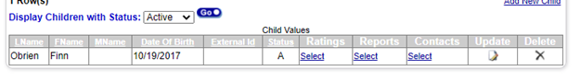

1. After you click on Ratings you will see the chart below, select Strategies under Options.

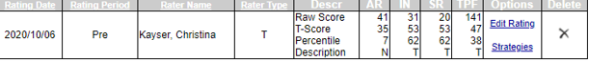

1. After you click strategies, you will see a lengthy document that illustrates the areas of need and several strategies for each area! You will see this chart at the top of the page:

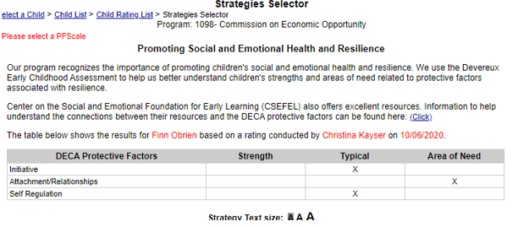

1. Then you will see a list of strategies for each area.  I will share the strategies for Initiative here.  You will see the checkboxes next to the strategies, this allows you to check off what activities you want to use in the classroom and/or send home, the system will create a PDF or html document (in English or Spanish) that will just have the strategies you want to use or send home on one document.
2. Click home for the desired report.
3. Click create a PDF document. This will download the letter with strategies for the parents. Please print and give to families at Parent Teacher Conferences.

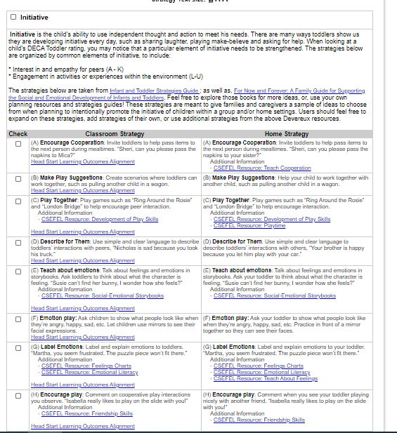

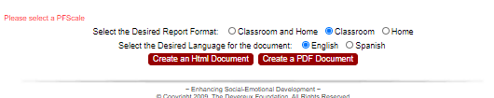

**How to see what questions assess what areas of social/emotional development.**

1. Once you are logged into system, click View Ratings/Reports

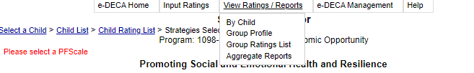

1. Select the child, and under report type select single rating, and choose the rating

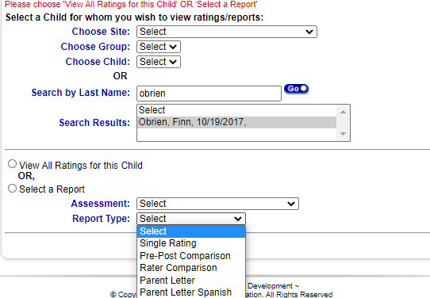

1. A document will load, on page 3 of that document you will see what questions are under what area.