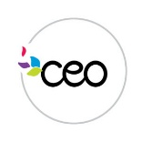
What is In-Kind???
In-kind is an extension of the classroom and includes activities you do with your child all the time! Because we are federally funded, a requirement of our grant is to get 25% of in-kind (donations and volunteering). This allows us to continue serving children and families in Rensselaer County.

Each month, there will be a new sheet with your child’s name on it in a binder in the classroom.
What we need from you:
- Print your name on the top as the volunteer.
- Fill in the time for each event you attend.
- Fill in the amount of time you spend on school readiness activities at home.
- Keep track of how long you read with your child at home. If you read 5 minutes every night, that is 2 ½ hours of in-kind for the month!
- Sign the bottom.
Other ways to earn in-kind hours:
- Volunteering in the classroom.
- Preparing materials at home for use in the classroom.
- Join Policy Council.
- Participate in your center’s Family Connections Committee.
