Individual Goals for children are created on a quarterly basis. Headstart children will have three goals per program year, Early Headstart children will have four. Each individual goal should be created based on input from the child’s family and information from their most recent assessments (ASQ, Deca or checkpoints).
Goals should be
- Related to a specific skill that the child is working on
- Observable – something you can see or hear the child do
- Achievable – based on the child’s development

*Note that individual goals are shared with families at Parent Teacher Conferences so phrasing matters!*

Below are examples of how individual goals may progress throughout the year for a child in each age group. You must also write in an activity that will support the child in achieving this goal. When choosing your activities, consider what time of day would be best for practicing the skill. You may use Intentional Teaching Cards from the curriculum or write in activities of your own.
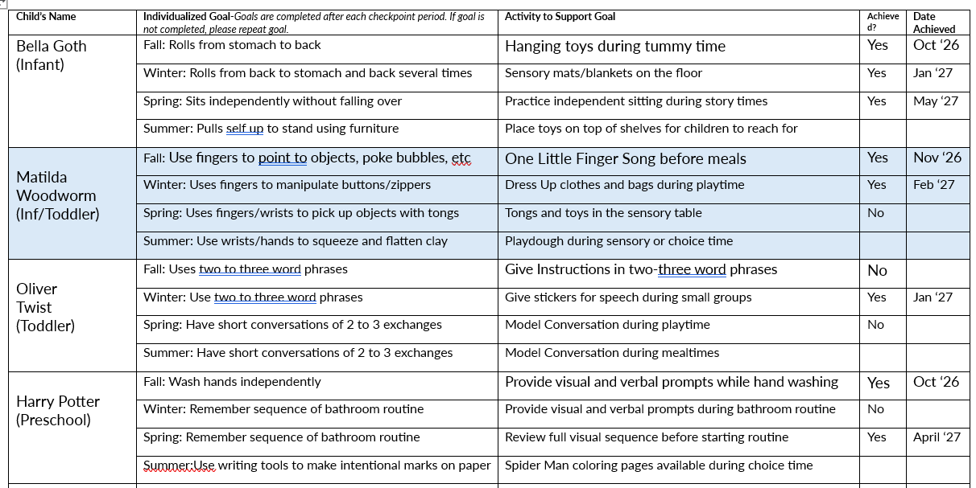

TIP: It may be helpful to refer to your Class Profile on Teaching Strategies to create children’s goals.
Selecting Children’s Goals based on your Class Profile
- From your Teaching Strategies home page, click Report on the bottom left column

- Find the box for Class Profile and click it. Be sure that you’re viewing the correct Checkpoint Period, displayed on the top right of the page. To change the checkpoint period, click the top left Filters button and use the drop-down menus to select the correct criteria.

- Note areas where children are below widely held expectations (the colored areas), then refer to the full color band progression for that area. You can find these in the Objective for Learning and Development textbooks or through the library on Teaching Strategies.

- Identify where the child is currently on the progression band, then find the next highest level with examples of observable behaviors. (For example, if the child currently falls into level 2 or 3, look to level 4)

- You may choose one of the observable behaviors, or create a variation of it, as the child’s individual goal.

