Adding a child
Note: Note: Only create a new profile for children who are new to CEO. Transfers from another classroom, center or home-based care will have their accounts transferred as well. See your Ed Specialist with any questions.

- At the top of the page, select e-DECA Management
- From that menu, select Manage Children and then Create a New Child Record
- Enter the child’s last name, first name, date of birth and entry date (start date).
Note: Please refer to COPA for correct information and spelling.
- Under Site/Group Assignments, select the appropriate classroom for the child and move it to the right using the orange arrow key.
- Click Submit and look for a message in red text confirming your changes.

Completing an e-DECA
Note: It’s best practice for teachers to spend at least one month with a child before completing their eDECA. If you need assistance with child assessments, please reach out to your Ed Specialist.

- At the top of the page select Input Ratings and then By Child (online)
- Choose the correct Site, Group and Child from the drop-down menus
- Choose the age-appropriate Record Form from the drop-down and click Submit
- On the next page, choose a Rater from the drop-down menu(This should be yourself)
- Choose a Rating Period and input the Rating Date.
Note: Assessments done for a child’s 45 day deadline will be labeled PRE. During the regular program year, assessments done in the fall are PRE, those done in the winter are POST.

- Complete the form by selecting the circles for how often the child engages in each behavior.
- Click Save This Rating at the bottom of the screen.

Printing eDECA Strategies for Parent Teacher Conferences
- At the top of the screen click View Ratings/Reports and then By Child
- Select the correct Site, Group and Child from the drop down menus
- In the lower section click the circle for View All Ratings for this Child
- Click Submit
- On the following page, find the most recent Rating Date and select Strategies (highlighted in blue) under the options column in that row.
- The next page is the Strategies Selector. As you scroll down you’ll see boxes for each of the DECA protective factors (Initiative, Attachment/Relationships and Self-Regulation).
- Select at least one strategy per area by checking the box at the top left of each section, and then at least one box under the Check column beside the strategies you’ve chosen.
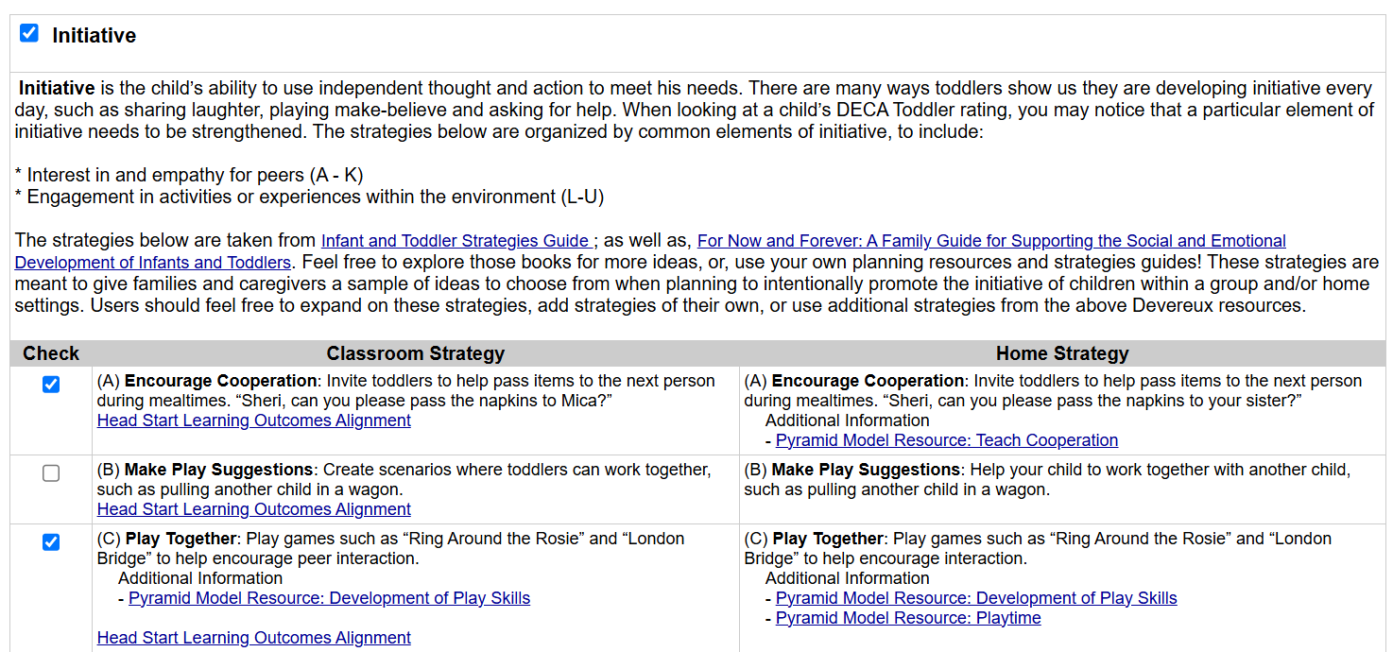
See Below:

:

- Once strategies are checked scroll to the bottom of the page
- For Select the Desired Report Format choose Home
- Click Create a PDF Document, this will open your report as a PDF where you may print or download the file.

